College of DuPage Meteorology
Forecasting Class: Isoplething Lab
http://weather.cod.edu/labs/

What is an isopleth?

Isopleth: n : a line drawn on a map connecting points having the same numerical value of some variable (from dictionary.reference.com).

Isoplething is a way for scientists to be able to organize data points so that it is easier to visually understand what is going on. You have seen isoplething on TV weathercasts your entire life but may not have realized it. The following map is an example of a classic temperature forecast map that you see on TV.

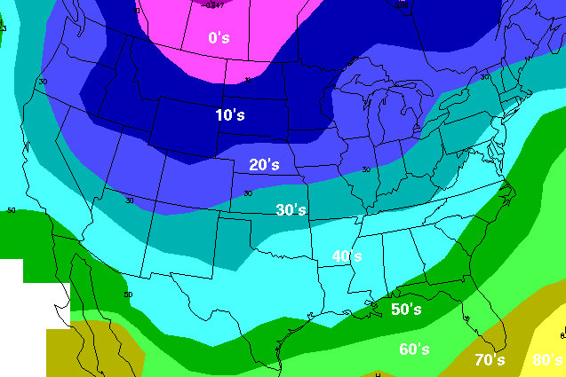

Those areas that say 30’s and are in the color “blue” represent a place where every point will record a temperature between 30 and 39. The actual place where the colors change is the isopleth line. The line, or isopleth, on the north side, where light blue becomes dark blue is the 30 degree *isopleth*. Everything on that line is equal to 30 degrees. Anything north of there is less than 30 and anything south of there is greater than 30. To most, this makes complete sense. And, it is easier to read a map like this then it would be for a bunch of temperatures plotted instead, like the next example.

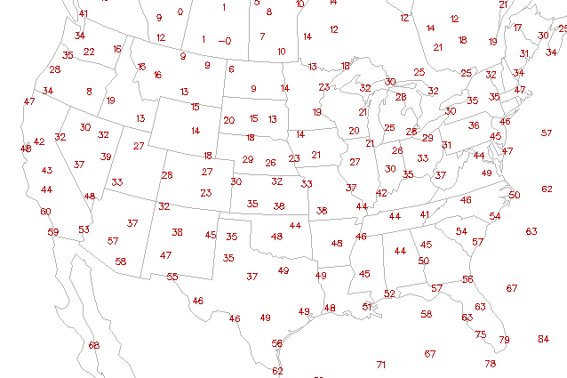

Another example of isoplething that you have often seen on TV is the Jet Stream image. Often it is just a big arrow over the US. But some, like Tom Skilling, show the true jet stream analysis by showing an isopleth analysis of the winds.

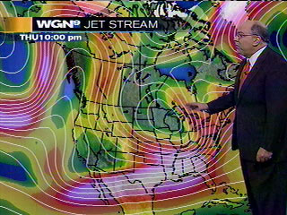

Isoplething is the generic term for any data that is contoured. However, individual data that is analyzed has its own name. Lines of constant temperature, like we talked about above are called Isotherms. Iso, meaning same, and therm, meaning “thermal” (temperature). So an Isotherm is defined as, “A line of constant temperatures”.

So, what do the following isopleth terms define? (You may have to look these up)

Isobar:
A) Line of constant alcohol
B) Line of constant pressure
C) Line of constant wind speed
D) Line of constant humidity

Isotach
A) Line of constant pressure
B) Line of constant wind speed
C) Line of constant push pins
D) Line of constant humidity

Isallobar
A) Line of constant wind chill
B) Line of constant soap
C) Line of constant pressure change
D) Line of constant dewpoint

Isotherm
A) Line of constant pressure
B) Line of constant wind speed
C) Line of constant temperature
D) Line of constant thermoses

Isodrosotherm
A) Line of constant dewpoint
B) Line of constant convergence
C) Line of constant wind speeds
D) Did you pick A? I would have picked A.

Isoheight
A) Line of constant C.A.P.E.
B) Line of constant pressure
C) Line of constant basketball players
D) Line of constant height

Doing your own isoplething!

1) Review the next page’s “Rules of Isoplething” .

2) Using Figure 1a, you will see an example of a grid of temperatures found in and around Illinois that was already analyzed (marked with isotherms). Use this as a guide for how to analyze this particular type of map (which you will do in step 3).

3) Now, with Figure 1b, it is time for you to analyze the temperatures! Start by doing the 18 degree isotherm. Now, analyze for every two degrees (i.e. 20, 22, 24). Take your time and be careful! Isoplething seems very difficult at first, to some, but only through time and practice does it become an easy task.

4) Using Figure 2a, you will see an example of an isotach analysis at 500 millibars. 500 millibars is, essentially, halfway up the troposphere, the mid-levels as we call them. Doing an isotach analysis gives you an idea of the current “jet stream” in the mid-levels. This is important for understanding where storms might track, the temperature regime of the US, etc, etc.

5) Using Figure 2b, analyze the jet stream for this map. Start by analyzing winds that are 70 knots or greater. Analyze winds in 20 knot increments (i.e. 70kts, 90kts, etc). If you have forgotten how to read wind barbs, here is a chart that will help you (all of these winds would be from the east, or easterly winds).

