EL NIÑO/SOUTHERN OSCILLATION (ENSO) DIAGNOSTIC DISCUSSION

issued by

CLIMATE PREDICTION CENTER/NCEP/NWS

12 December 2024

ENSO Alert System Status: La Niña Watch

Synopsis: La Niña conditions are most likely to emerge in November 2024 - January 2025 (59% chance), with a transition to ENSO-neutral most likely by March-May 2025 (61% chance).

ENSO-neutral continued in November, with near-average sea surface temperatures (SSTs) observed across the central and eastern equatorial Pacific Ocean (Fig. 1). Similar to the last couple of months, the latest weekly Niño indices ranged from +0.1°C (Niño-1+2) to -0.4°C (Niño-3; Fig. 2). Below-average subsurface ocean temperatures persisted (Fig. 3) across the east-central and eastern equatorial Pacific Ocean (Fig. 4). Over the western and central equatorial Pacific, low-level wind anomalies were easterly and upper-level wind anomalies were westerly. Convection was suppressed over the Date Line and was enhanced over western Indonesia (Fig. 5). The traditional and equatorial Southern Oscillation indices were positive. Collectively, the coupled ocean-atmosphere system reflected ENSO-neutral.
The dynamical models in the IRI plume continue to predict a weak and a short duration La Niña, as indicated by the Niño-3.4 index values less than -0.5°C (Fig. 6). This prediction is also reflected in the latest North American Multi-Model Ensemble (NMME), which continues to predict slightly cooler SSTs and weak La Nina conditions. The forecast team leaned toward predicting an eventual onset of weak and short-lived La Nina conditions, based on the model guidance and current atmospheric anomalies. Weak La Niña conditions would be less likely to result in conventional winter impacts, though predictable signals could still influence the forecast guidance (e.g., CPC's seasonal outlooks). In summary, La Niña conditions are most likely to emerge in November 2024 - January 2025 (59% chance), with a transition to ENSO-neutral most likely by March-May 2025 (61% chance; Fig. 7).
This discussion is a consolidated effort of the National Oceanic and Atmospheric Administration (NOAA), NOAA’s National Weather Service, and their funded institutions. Oceanic and atmospheric conditions are updated weekly on the Climate Prediction Center website (El Niño/La Niña Current Conditions and Expert Discussions). Additional perspectives and analyses are also available in an ENSO blog. A probabilistic strength forecast is available here. The next ENSO Diagnostics Discussion is scheduled for 9 January 2025. To receive an e-mail notification when the monthly ENSO Diagnostic Discussions are released, please send an e-mail message to: ncep.list.enso-update@noaa.gov.

Climate Prediction Center
National Centers for Environmental Prediction
NOAA/National Weather Service
College Park, MD 20740

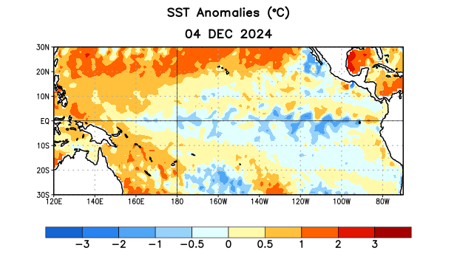
Figure 1. Average sea surface temperature (SST) anomalies (°C) for the week centered on 4 December 2024. Anomalies are computed with respect to the 1991-2020 base period weekly means.

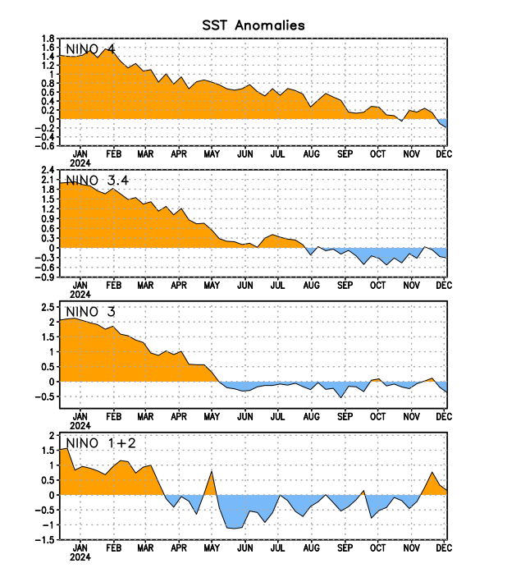
Figure 2. Time series of area-averaged sea surface temperature (SST) anomalies (°C) in the Niño regions [Niño-1+2 (0°-10°S, 90°W-80°W), Niño-3 (5°N-5°S, 150°W-90°W), Niño-3.4 (5°N-5°S, 170°W-120°W), Niño-4 (5ºN-5ºS, 150ºW-160ºE)]. SST anomalies are departures from the 1991-2020 base period weekly means.

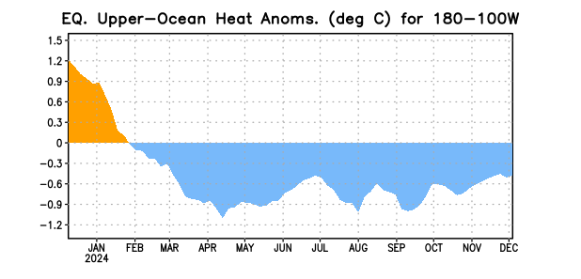
Figure 3. Area-averaged upper-ocean heat content anomaly (°C) in the equatorial Pacific (5°N-5°S, 180º-100ºW). The heat content anomaly is computed as the departure from the 1991-2020 base period pentad means.

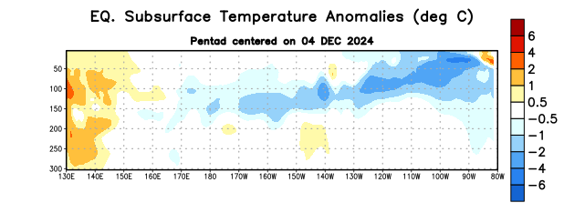
Figure 4. Depth-longitude section of equatorial Pacific upper-ocean (0-300m) temperature anomalies (°C) centered on the pentad of 4 December 2024. Anomalies are departures from the 1991-2020 base period pentad means.

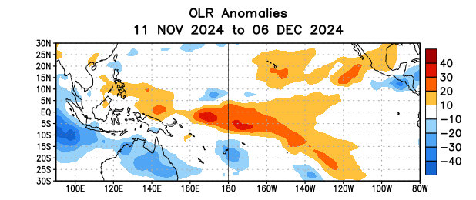
Figure 5. Average outgoing longwave radiation (OLR) anomalies (W/m²) for the period 11 November – 6 December 2024. OLR anomalies are computed as departures from the 1991-2020 base period pentad means.
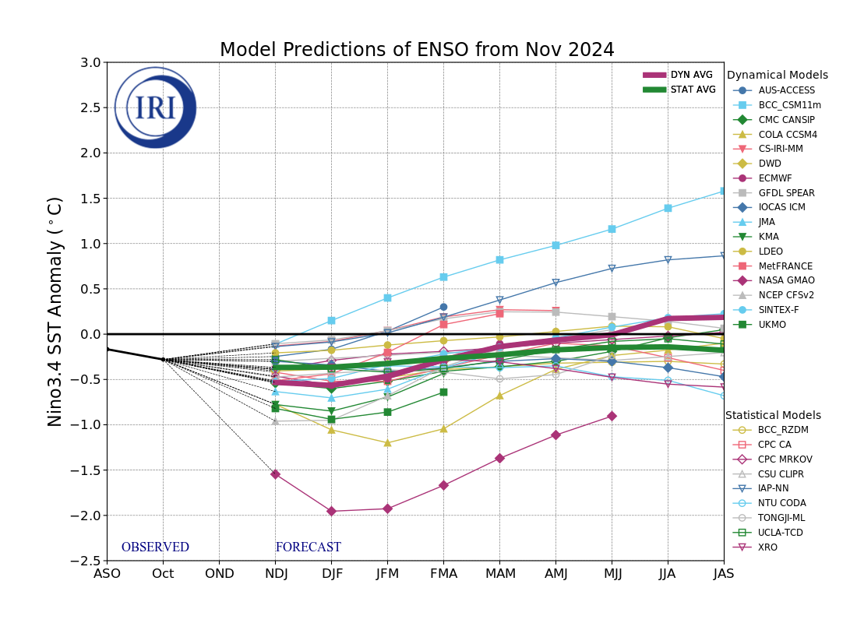
Figure 6. Forecasts of sea surface temperature (SST) anomalies for the Niño 3.4 region (5°N-5°S, 120°W-170°W). Figure updated 19 November 2024 by the International Research Institute (IRI) for Climate and Society.

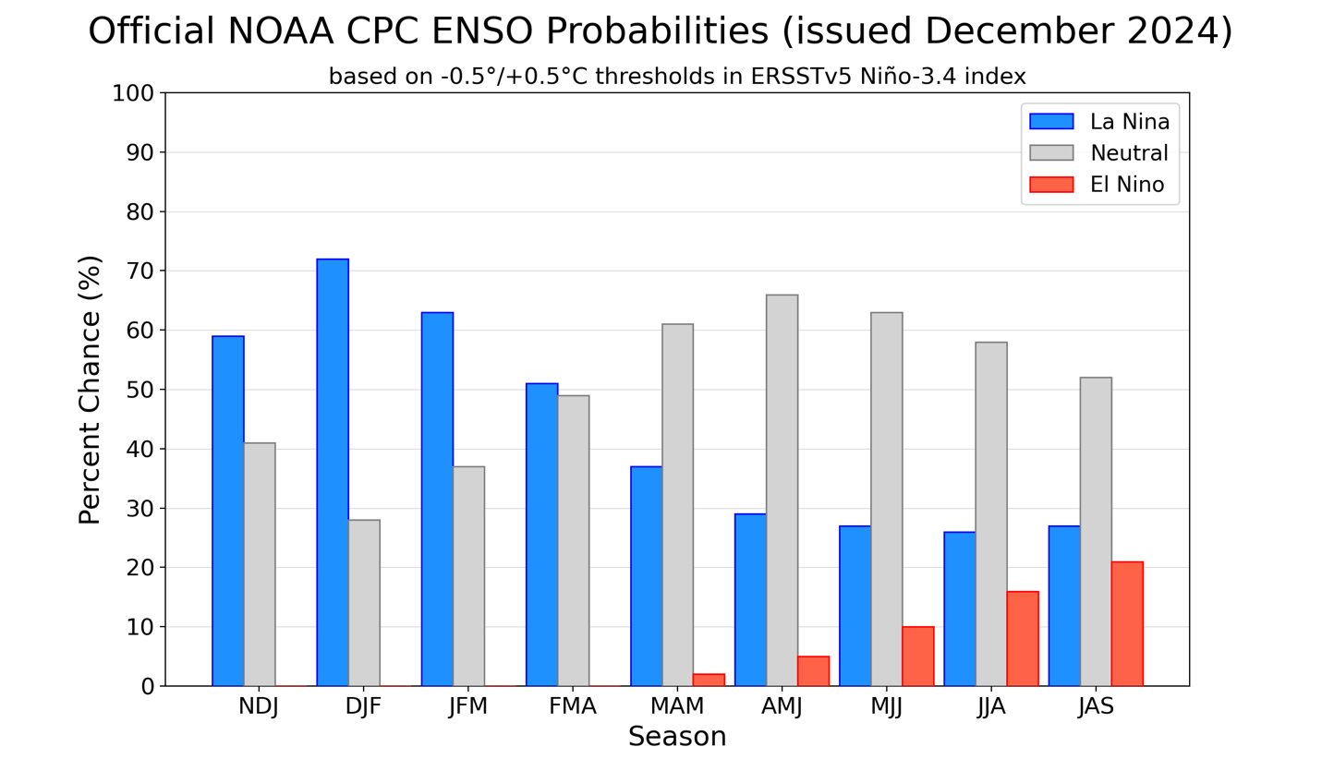
Figure 7. Official ENSO probabilities for the Niño 3.4 sea surface temperature index (5°N-5°S, 120°W-170°W). Figure updated 12 December 2024.

