Appendix S1: A map of fires recorded for CIRO between 1926 and 2005.

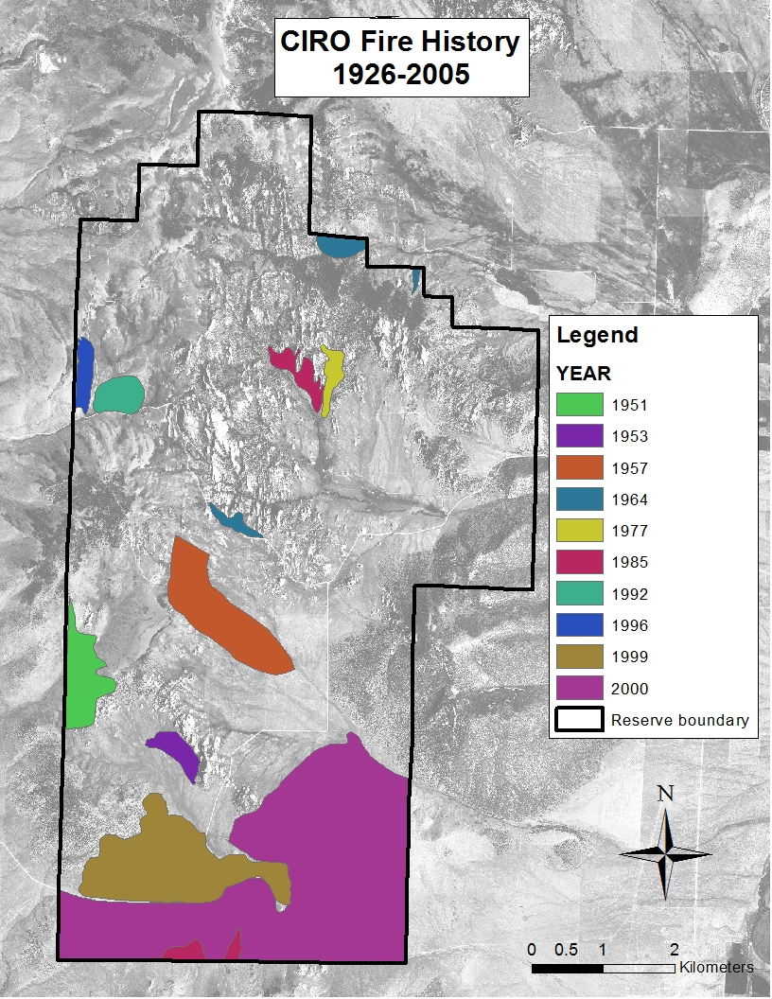

Data Sources:

1) Fire history: Morris LA (2006b) Fire history of the City of Rocks National Reserve from 1926 to 2005. Unpublished report. Logan, UT: Utah State University.

2) Base image: 2009 NAIP image (USDA Farm Service Agency).